# AGILE MODEL

* Agile is a model wherein we develop the software in an incremental and iterative process.
* They came up with this model in order to overcome the drawbacks that were there in the traditional model. Here we build large products in shorter cycles called Sprint.

**Scrum:**

It is the process used to build an application in agile model.

**Scrum team:**

It is the group of Engineers working towards completing committed features or stories.

1. Generally, scrum team will have 7-12 members.
2. It includes Shared team and Core team members
3. Core team includes Scrum master, Development Engineer and Test Engineer.
4. Shared team includes Architect, Product Owner, Database admin, network admin, UI and UX designers, BA.
5. Scrum master leads this entire scrum team and he facilitates everyone to complete their task.

**Product Backlog:**

It is a prioritized list of stories or requirements that must be developed in the complete project.

1. Generally, Product owner, Customer, Business analyst, architect, Scrum master will be involved in building it.
2. Generally, stories in product backlog need not be in detail.

**Sprint Backlog:**

It is a list of stories and the associated task committed by the scrum team that must be delivered within one sprint.

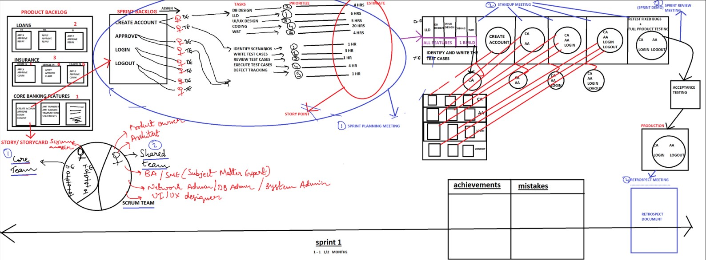

**I. Sprint Planning Meeting:**

* 1. Here the entire scrum team sits together and pulls the stories from the product backlog.
  2. Scrum master assigns each story to development engineer and test engineer.
  3. Now each engineer derives the tasks to be completed to build the stories.
  4. Each engineer will estimate the time taken to complete each task i.e. they derive the story point.

*Following are the roles played by different people in Sprint planning meeting***:**

*1. Scrum master:*

1. This complete meeting is driven by the scrum master.
2. His prime role is to facilitate the complete meeting and co-ordinate between all stakeholders

*2. Product owner:*

*a.* He clarifies if there are any questions related to stories or requirements.

1. *Development Engineer:* 
   1. He should derive the task for building every story.
   2. He prioritizes which story to be built first and which story to build later in the sprint.
   3. He prioritizes the tasks.
   4. He derives the story point.
2. *Test engineer:* 
   1. He derives the task to be completed to test each feature or story.

Ex: Create a/c : Identify scenarios

Write test cases

Review test cases

Execute test cases

Defect tracking

**II. Daily Stand-Up Meeting/ Role Call Meeting/ Daily Scrum Meeting:**

* 1. Here the entire scrum team meets.
  2. This meeting is completely driven by the scrum master.
  3. Here every engineer should explain:
     + What they have done yesterday?
     + What were the impediments/hurdles they faced yesterday?
     + What are the Activities he is planning to do today?
     + What are the impediments he is expecting in order to complete today’s task?
  4. The scrum master tries to solve certain impediments right there in the meeting. If it takes too much time then scrum master notes it down in **‘Impediment backlog’** and solves it later.
  5. Generally, this meeting should be completed within 10-15 mins.
  6. This meeting should be conducted at the beginning of the day.
  7. Here everybody should stand-up in the meeting so that people only talk to the point.

**III. Sprint Review Meeting:**

1. Sprint review meeting should be done at the end of the sprint, where the engineers will give a demo to the product owner.
2. They will also discuss how to plan for the next sprint.

**IV. Retrospective Meeting**

1. Here the entire scrum team meets and discusses all achievements (good process followed) and mistakes (wrong activities performed) and it will be documented. This document is called as **Retrospect document.**
2. When the next sprint starts while doing sprint planning meeting, we refer this document & we plan it in such a way that old mistakes should not be repeated and good activities are once again adopted.